PDPs in Employee Portal
Employee Portal
- Click Create a New Plan for the current school year.
- Fill Out Dates and Click Add
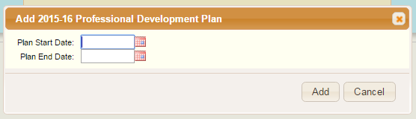
- The Screen Below will appear, click save.
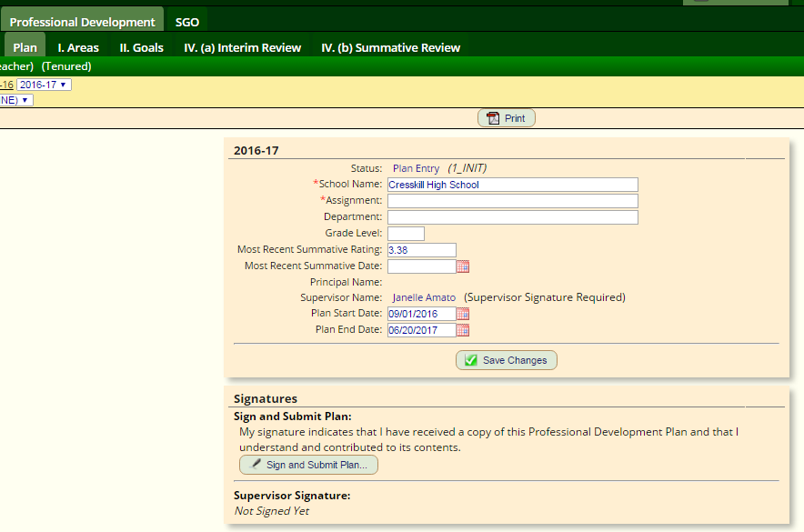

- Leave I. Areas Blank
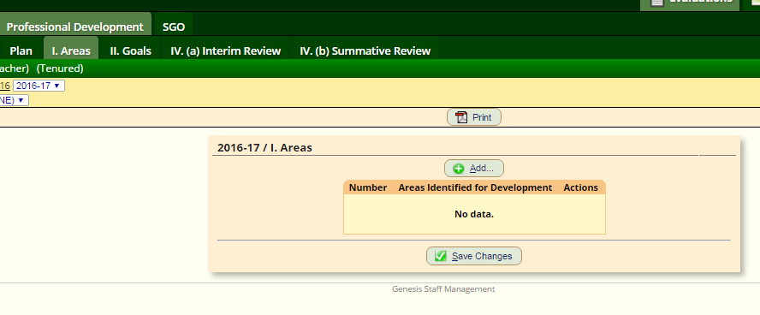

- Click on II. Goals
- Click Add. Type in information for 1st PDP goal. Click Add. Type in information for 2nd PDP goal.
- Hit Save

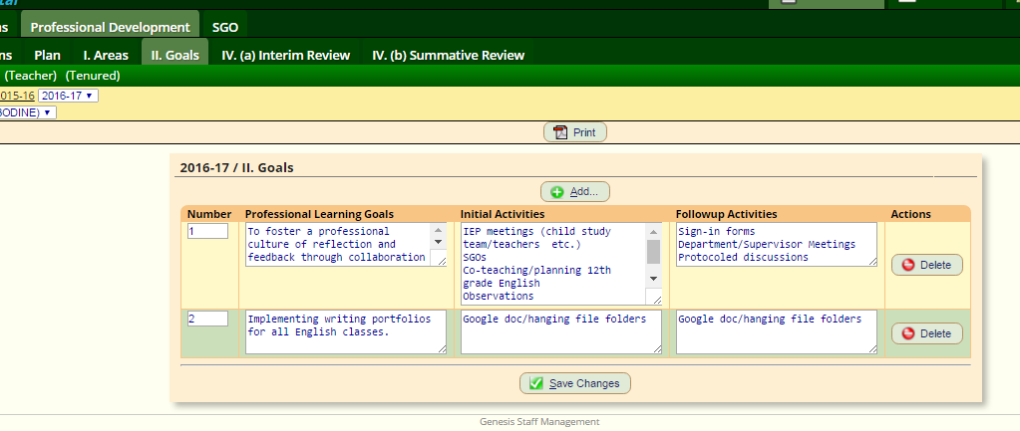

Fall Entry: PDP Finalized in Genesis Employee Portal
- Speak with Supervisor & make any necessary changes
- Sign PDP

Mid-Year Entry: PDP Interim Review Submitted
- Click Add. Fill out information for 1st PDP. Click Add. Fill out information for 2nd PDP. 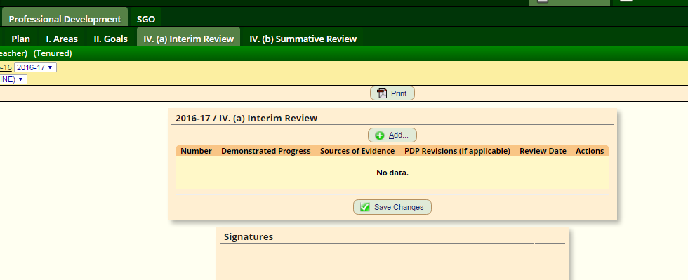

- Demonstrated Progress: Summary of what has been done thus far to accomplish this goal (bulleted list)
- Sources of Evidence: List of PDs, trainings, workshops, course, etc & dates
  - Optional: Upload Sources of Evidence in Domain 4
- PDP Revisions: If revising speak with supervisor.
- Sign PDP.

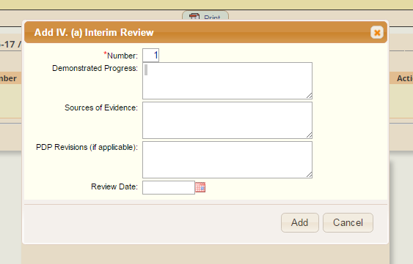

Final Entry: PDP Summative Review Submitted
- Click Add. Fill out information for 1st PDP. Click Add. Fill out information for 2nd PDP.
- Professional Learning Goals: Copy & Paste Goals
- Expectations Met: Y or N
- Sources of Evidence: List of PDs, trainings, workshops, course, etc & dates since Interim Report
Optional: Upload Sources of Evidence in Domain 4

